21 Oct 2020 Rinoy Kuriyakose R3 56

**Experiment : 10**

**Aim:**

Write a Java program that read from a file and write to file by handling all file related exceptions

**Concepts Used:**

File Handling.

**Algorithm:**

Algorithm FileHandling

1. import java.io.*

2. throws IOException

3. Initialise File obj object to create the file

4. Initialise FileWriter object on the file

5. Read the input from User(using BufferedReader Class) and write to the file

6. while((i = fr.read()) != -1) // Reading From the file

7. print (char)i

8. endwhile

**Program:**

import java.io.*;  
  
public class FileHandling {  
 public static void main(String[] args) throws IOException {  
 String content;  
 int i;  
 BufferedReader br=new BufferedReader(new InputStreamReader(System.in));  
 System.out.println("\n Creating File \n");  
 try {  
 File myObj = new File("myDocument.txt");  
 if (myObj.createNewFile()) {  
 System.out.println("File created : " + myObj.getName());  
 } else {  
 System.out.println("File already exists.");  
 }  
 } catch (IOException e1) {  
 System.out.println("An error has occurred during File Creation.");  
 }  
 System.out.println("\n Writing to File \n");  
 try {  
 FileWriter myWriter = new FileWriter("myDocument.txt");  
 System.out.print("Enter the Content : ");  
 content=br.readLine();  
 myWriter.write(content);  
 myWriter.close();  
 System.out.println("Successfully wrote to the file.");  
 } catch (IOException e2) {  
 System.out.println("An error occurred during writing to File.");  
 }  
 System.out.println("\n Reading from File\n");  
 FileReader fr=null;  
 try  
 {  
 fr = new FileReader("myDocument.txt");

while ((i=fr.read())!=-1){  
 System.out.print((char)i);  
 }  
  
 }  
 catch (FileNotFoundException e3)  
 {  
 System.out.println("File not found");  
 }  
 fr.close();  
 }  
}

**Output:**

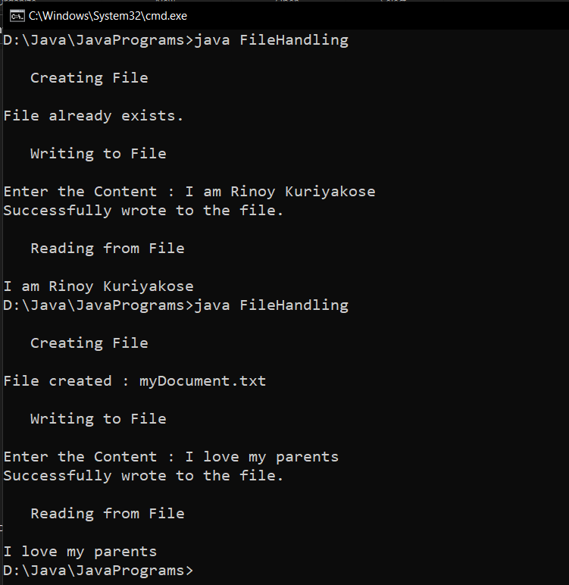

**Result:**

File handling is carried out in a Java program.

21 Oct 2020 Rinoy Kuriyakose R3 56

**Experiment : 11**

**Aim:**

Write a Java program that reads a line of integers, and then displays each integer, and the sum of all the integers (Use String Tokenizer class of java.util)

**Concepts Used:**

BufferedReader class, StringTokenizer class.

**Algorithm:**

Algorithm StringTokens

1. import java.util.* and import java.io.*

2. sum = 0

4. read the numbers separated by comma

5. Initialise StringTokenizer object st on num

6. while(st.hasMoreTokens())

7. num = Integer.parseInt(st.nextToken())

8. sum += num

9. endwhile

10. Print sum

**Program:**

import java.util.StringTokenizer;  
import java.io.*;  
public class SumOfNumbers{  
 public static void main(String args[]) throws IOException{  
 String num;  
 int sum =0;  
 BufferedReader br=new BufferedReader(new InputStreamReader(System.in));  
 System.out.print("Enter Numbers (seperated with commas) : ");  
 num=br.readLine();  
 StringTokenizer st = new StringTokenizer(num,",");  
 while (st.hasMoreTokens()) {  
 sum=sum+Integer.parseInt(st.nextToken());  
 }  
 System.out.print("Sum is : "+sum);  
 }  
}

**Output:**

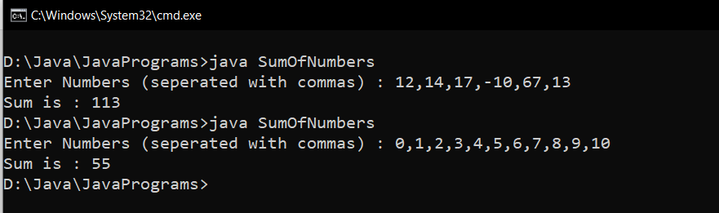

**Result:**

A line of integers are read from the user and they are printed along with their sum.